***bLogic Specification Template***

|  |  |  |  |
| --- | --- | --- | --- |
| **Student** | Gerardo Galan Garzafox | **Program** | 7 |

|  |  |
| --- | --- |
| **Class Name** | IO |

|  |  |
| --- | --- |
| **Method Name** | read() |

|  |  |
| --- | --- |
| **Parameters** | void |

**Include the image of the activity diagram created for the program:**

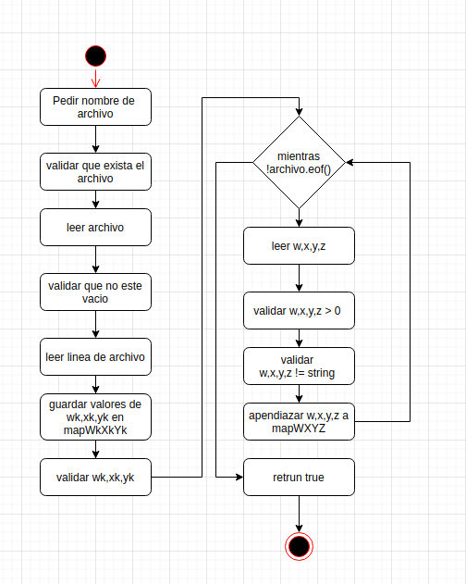

|  |  |
| --- | --- |
| **Class Name** | IO |

|  |  |
| --- | --- |
| **Method Name** | print() |

|  |  |
| --- | --- |
| **Parameters** | data:vector<long double> |

**Include the image of the activity diagram created for the program:**

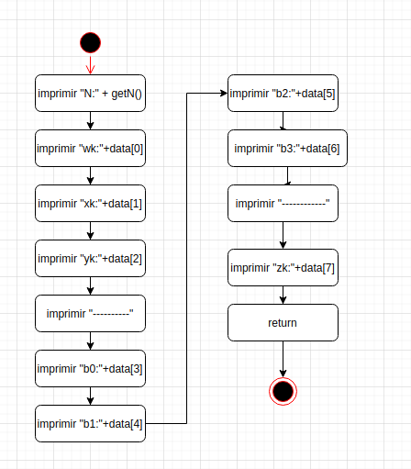

|  |  |
| --- | --- |
| **Class Name** | Calc |

|  |  |
| --- | --- |
| **Method Name** | Calc() |

|  |  |
| --- | --- |
| **Parameters** | map<char,vector<double>>mapWXYZ |
|  | map<string,double>mapWkXkYk |

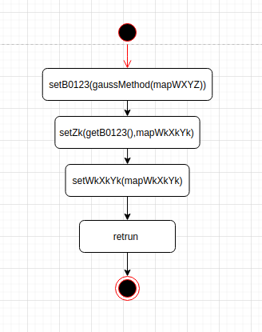

|  |  |
| --- | --- |
| **Class Name** | Calc |

|  |  |
| --- | --- |
| **Method Name** | calcZk():double |

|  |  |
| --- | --- |
| **Parameters** | map<string,double> mapB0123 |
|  | map<string,double>mapWkXkYk |

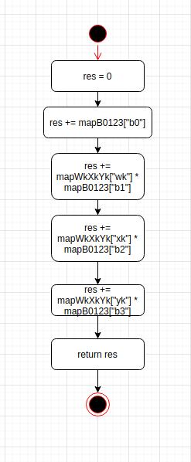

|  |  |
| --- | --- |
| **Class Name** | Calc |

|  |  |
| --- | --- |
| **Method Name** | getData():vector<double> |

|  |  |
| --- | --- |
| **Parameters** | null |

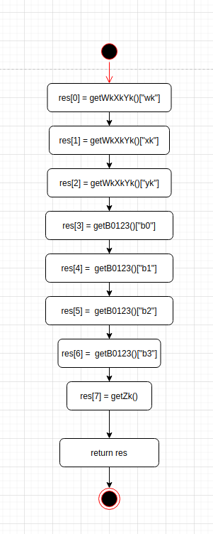

|  |  |
| --- | --- |
| **Class Name** | Calc |

|  |  |
| --- | --- |
| **Method Name** | sumV1xV2():double |

|  |  |
| --- | --- |
| **Parameters** | v1 vector<double> |
|  | v2 vector<double> |

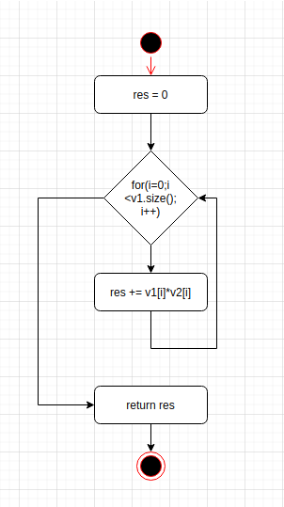

|  |  |
| --- | --- |
| **Class Name** | Calc |

|  |  |
| --- | --- |
| **Method Name** | gaussMethod():map<string,double> |

|  |  |
| --- | --- |
| **Parameters** | map<char,vector<double>> mapWXYZ |

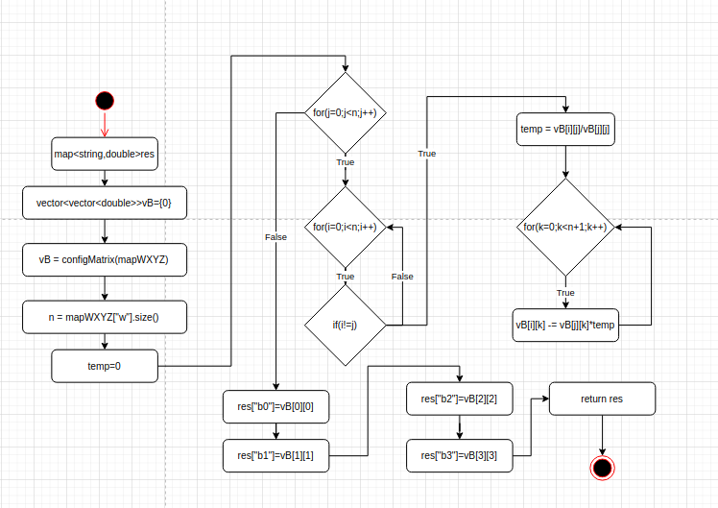

|  |  |
| --- | --- |
| **Class Name** | Calc |

|  |  |
| --- | --- |
| **Method Name** | configMatrix():vector<vector<double>> |

|  |  |
| --- | --- |
| **Parameters** | map<char,vector<double>> mapWXYZ |

